From: <https://marisol-nostromo.medium.com/the-unfinished-work-of-the-church-committee-f702ac8f94b1>

Date: 2020 Nov 08

**The Unfinished Work of the Church Committee**

[Marisol Nostromo](https://marisol-nostromo.medium.com/?source=post_page-----f702ac8f94b1--------------------------------)

[Marisol Nostromo](https://marisol-nostromo.medium.com/?source=post_page-----f702ac8f94b1--------------------------------)

[8 hours ago·7 min read](https://marisol-nostromo.medium.com/the-unfinished-work-of-the-church-committee-f702ac8f94b1?source=post_page-----f702ac8f94b1--------------------------------)

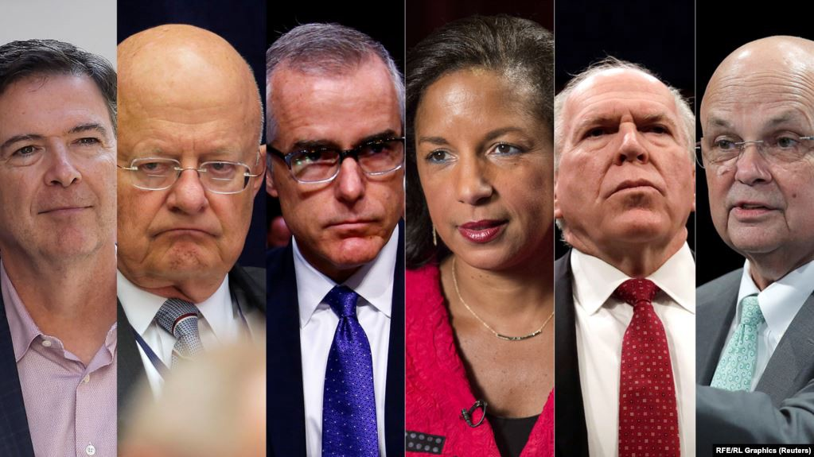

James Comey, James Clapper, Andrew McCabe, Susan Rice, John Brennan, Michael Hayden

[According to Merriam-Webster](https://www.merriam-webster.com/dictionary/the%20secret%20police), a “secret police” is “a police organization that is run by a government and that operates in a secret way to control the actions of people who oppose the government.” Of course, in this day and age, it’s not easy to define “the government”. We live in an oligarchical society. There are elected officials, including the President, who stay in office for a fixed amount of time and have a certain amount of power to change the way that things are done. But on the other hand, there are permanent institutions, both within the government itself and within society at large, that also wield significant power and are responsible for safeguarding the interests of the oligarchy, should they be threatened by the policies of the temporary, elected government.

There are various ways to describe this superstructure of oligarchic rule. One term which has become popular of late is “Deep State.” Because the term has been used by Donald Trump, it has been ridiculed in the press as a “conspiracy theory,” an expression which is often used to identify an “unauthorized narrative”. A more technical term, favored by the British and the [neocons](https://marisol-nostromo.medium.com/what-are-the-neocons-really-19247b03a436), is “Continuity of Government” (COG.) There has been plenty of [analysis](https://www.globalresearch.ca/the-hidden-government-group-linking-jfk-watergate-iran-contra-and-91/5407542) of this concept, some well-founded, some highly speculative.

A few things are self-evident here. One is that there is a huge number of career civil servants working in all branches of government who don’t leave their jobs at the end of a 4- or 8-year presidential term. They remain, offering their professional experience, as well as their established political allegiances and ideological habits, to the incoming administration. Secondly, these career professionals are connected in multiple ways to non-governmental institutions with which they have formed closed working relationships, such as the media and the financial community, or the arms industry (the famed “[Military Industrial Complex](https://www.youtube.com/watch?v=Gg-jvHynP9Y&t=5s).”[1])

Agencies such as the Central Intelligence Agency (CIA) and Federal Bureau of Investigation (FBI) devote much of their efforts to covert activity, and these agencies have at times clashed with elected officials. There have been allegations that these agencies are more loyal to permanent oligarchic institutional forces than to any temporary occupant of the White House. There are even compelling reasons to believe that these secretive agencies have been deployed against U.S. elected officials and even presidents, including Donald Trump.

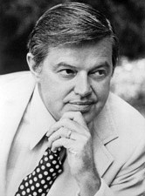

Senator Frank Church

In the early 1970s there were troubling revelations about covert operations, including illegal spying on American citizens and assassinations of dissident leaders such as [Fred Hampton.](https://www.archives.gov/research/african-americans/individuals/fred-hampton) Growing public concern about these abuses led to the formation of the United States Senate Select Committee to Study Governmental Operations with Respect to Intelligence Activities, better known as the Church Committee after its chairman, Democratic Senator Frank Church of Idaho. Creation of the Committee was approved on January 27, 1975 by the U.S. Senate. It published an extensive final report in April of 1976.

The Committee investigated the activities of the CIA and FBI, as well as the National Security Agency (NSA) and the Internal Revenue Service (IRS). It investigated assassinations of foreign leaders, unauthorized surveillance of U.S. citizens, and other covert operations. Efforts were made by political leaders, including President Gerald Ford, to keep these findings secret. These efforts were only partially successful.

Some of the projects which were exposed by the Church Committee included:

* COINTELPRO, the FBI program to infiltrate and disrupt dissident organizations
* MK-ULTRA, the CIA program to develop mind control techniques including the use of psychedelic drugs such as LSD
* Operation Mockingbird, the CIA program to manipulate the news media for propaganda purposes

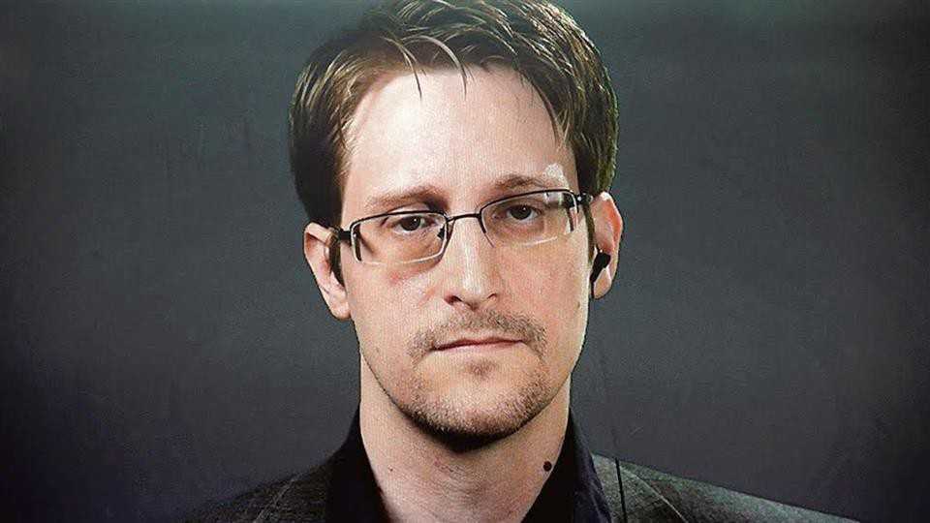

Edward Snowden

Typically, the agencies under investigation would issue a *mea culpa*and assure the public that these naughty activities had all been discontinued. However, new revelations over the past decades have demonstrated that nothing could be further from the truth. Of particular interest is the case of [Edward Snowden](https://edwardsnowden.com/frequently-asked-questions/), the NSA whistleblower who revealed the truly staggering extent of the unlawful surveillance being carried out on American citizens.

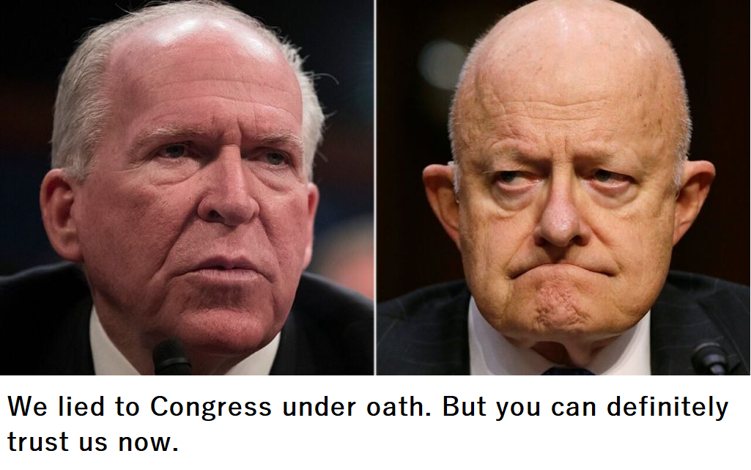

Some things which were once done with utmost discretion, such as the infiltration of the news media by the CIA under Operation Mockingbird, are now done completely out in the open without the public batting an eye. For example, former CIA Director John Brennan and former Director of National Intelligence James Clapper, who both lied under oath to the US Congress about illegal activity by the CIA and NSA, now hold high-profile positions at MSNBC and CNN respectively.

It was [Russiagate](https://consortiumnews.com/2020/10/19/patrick-lawrence-the-damage-russiagate-has-done/?fbclid=IwAR2RNJI47MnUrW7LEOvri2PbSImkAZCI-nYak6JBbvlh7YBldcevBBzIO1s) that brought into sharp relief the depth and breadth of CIA/NSA/FBI involvement in the manipulation of domestic politics. It originated in London, the great mecca of the neocons, with the preparation of the “Steele Dossier” by a “former” operative of MI6. For four years in the U.S., Russiagate was propagated through regular leaks of anonymous “assessments” from members of the “intel community” to their assets in the media, some of whom were themselves ostensibly retirees from the “intel community.”

These leakers were dutifully characterized in the media as courageous, patriotic whistleblowers, unlike those individuals such as Edward Snowden, Chelsea Manning or Julian Assange who revealed material that was embarrassing to the neocons. The [condemnation of those latter persons by Congressman Adam Schiff](https://www.wsws.org/en/articles/2019/09/30/pers-s30.html), who had [his own personal whistleblower](https://suindependent.com/time-ask-adam-schiff-informant-eric-ciaramella/)on tap for his impeachment effort, is also illuminating.

One organization which has earned the gratitude of the American public for shedding light on the malignant activities of the “intel community” is group of genuine, high-profile whistleblowers that calls itself [Veteran Intelligence Professionals for Sanity (VIPS).](https://www.commondreams.org/author/veteran-intelligence-professionals-sanity) They have played an important role in [debunking](https://consortiumnews.com/2017/07/24/intel-vets-challenge-russia-hack-evidence/) the story that Russia “hacked” the DNC servers and furnished information on DNC misconduct to Wikileaks.

But what has come out of the shadows and into full view during the past four years is a new sort of complex, where the covert agencies, the media, and the corporations which now monopolize social media, join forces to create an unprecedented, “total immersion” propaganda environment. Initially, the internet and social media appeared to be a “wild west” sort of venue where anyone could say anything. Much of the population soon began to prefer this as a source for news over the corporate media, and the neocons cried foul. [Facebook hastened to accomodate them](https://fair.org/home/facebooks-new-propaganda-partners/), bringing in the vociferously neocon Atlantic Council and the mother of all Regime Change organizations, the National Endowment for Democracy, as consultants in 2018 to help decide which voices should be silenced.

Not to be outdone, Twitter [hired a part-time officer in the British Army’s psychological warfare unit](https://www.middleeasteye.net/news/twitter-executive-also-part-time-officer-uk-army-psychological-warfare-unit) as senior executive with editorial responsibility for the Middle East in 2019. The following year Facebook upped the ante by [hiring the former Director-General of Israel’s Justice Ministry](https://electronicintifada.net/blogs/tamara-nassar/facebook-appoints-israeli-censor-oversight-board), a specialist in censorship, as a member of its new “oversight board.”

The FBI joined the fun, [seizing over 100 internet domains](https://news.antiwar.com/2020/11/04/doj-seizes-27-domains-claims-they-are-controlled-by-iran/) in late 2020 and claiming that they were operated by Iran. This included the site for the American Herald Tribune, an alternative press organ with a substantial following. The FBI Special Agent in charge issued a statement, saying that “Thanks to our ongoing collaboration with Google, Facebook, and Twitter, the FBI was able to disrupt this Iranian propaganda campaign and we will continue to pursue any attempts by foreign actors to spread disinformation in our country.”

However, it doesn’t stop with propaganda and censorship. During the presidential election of 2020, there was an escalated intervention by the secret police agencies into the electoral process. A few [courageous individuals](https://thehill.com/blogs/congress-blog/politics/485051-tulsi-gabbard-presidential-candidates-must-also-condemn-election) spoke out against this.

When election day arrived, numerous vote-counting anomalies were reported all around the country, partially obscured by deliberate disinformation, “fact-checking”, and general hysteria. One particularly noteworthy allegation was made by Sidney Powell, an attorney who has represented General Michael Flynn. She alleged that computer programs called HAMMER and SCORECARD, which had been developed for the intelligence agencies for use in rigging elections in other countries, had been used to benefit Biden in the election. Former NSA senior analyst and member of VIPS, Kirk Wiebe, explained the use of these cyber-weapons, and reported that the man who developed them, Dennis Montgomery, was prepared to testify to this effect:

The many allegations of fraud in the 2020 election may be the subject of controversy, litigation, and even civil unrest for possibly years to come. But at this point, can anyone argue that it is not urgent for the Congress to resume an investigation of misconduct by our secret police agencies, and that this time they not be satisfied with polite assurances that the bad behavior will cease? Trump has many warts, but there is a proper way to remove him from office, if that is what the electorate wants. A [color revolution](https://marisol-nostromo.medium.com/americas-color-revolution-343cdf1b1181), or any other form of coup run by secret police agencies, is odious.

*Thanks for reading. If you find this material interesting, perhaps you might contact Twitter and ask them why*[*my account was suspended*](https://marisol-nostromo.medium.com/i-was-suspended-by-twitter-for-what-4ed8be94858d)*on June 30 of this year. I would very much like to find out the reason.*

WRITTEN BY

[Marisol Nostromo](https://marisol-nostromo.medium.com/?source=post_sidebar--------------------------post_sidebar-----------)

Marisol is an arts aficionado and a social media habitué.

Following

6

6

1. A 3min 16sec discussion of Eisenhower's "Military-Industrial Complex" Speech Origins and Significance